
ERISWELL PARISH COUNCIL
Parish clerk: Nicola Glading
Phone: 01842 337488
Email: clerk@eriswellparishcouncil.gov.uk
Website: http://eriswell.onesuffolk.net

MINUTES
ERISWELL PARISH COUNCIL MEETING held at 7pm on July 28th 2026 at THE READING ROOM, ERISWELL
Present:
Present:
Cllr G Tolmie (Chairman)
Cllr J Foster (Vice Chairman)
Cllr A Bibbey
Cllr B Foster
Cllr D Horsman
Cllr A James
In attendance: Nicola Glading (parish clerk), Richard Keeble, Active Lakenheath Community Connector, West Suffolk District Cllr G Kelly, J Tillotson BEM (RAF) Suffolk County Cllr D Waldron, Mr A Blenkiron, MD Elveden Estates and 16 members of the public

2026/ 33 | CHAIRMANS WELCOME and RECORDING OF MEETING  The Chairman welcomed all to the meeting. Clerk to record for minutes only.
2026/34 | APOLOGIES FOR ABSENCE and speaker
- Councillors received apologies for absence
- Councillors consented to accept the apologies received (na)
2026/35 | DECLARATIONS of INTEREST
To receive Members’ declarations of Disclosable Pecuniary Interests
Cllrs J Foster and Cllr A James declared their interest (2026/39a.)

2026/36 | MINUTES OF THE MEETING HELD in JUNE 2026
 | - The minutes of the Parish Council meetings held in June 2026 were authorised.
 | - Business remaining from the meeting not on this agenda: none
2026/37 | PUBLIC PARTICIPATION
A resident commented that the green spaces at Lords Walk unify the community, and are good for mental health too.
- Q: How much and involvement is there between PIP and planning?
A: There is a meeting on Friday evening at Lakenheath Village Hall at 5pm, specifically, most of the PIP board members will be there. The objective is to list peoples ideas, an opportunity to bring projects to the fore. Ask PIP to consider compulsory purchase some land. Cllr Tolmie will circulate a map of the area which should stimulate ideas. Also, there will be an `ideas` stand at Lakenheath Fete on Saturday 1st August, and a stand at the Fun Day on 10th August.
Q: Would we be able to purchase the land?
A: Not yet known, up to the community to come up with ideas
Lakenheath, Sedge Fen, Undley and Lords Walk all involved.
Q: Has Mr Shipp asked Elveden about the trees in the belt?
A: Ecological survey reports no sign of endangered species.
Q: People were promised hotel, play park, etc
A: The dream of a landscaped, well serviced area was `sold` to you. The Parish Council discusses Lords Walk at all meetings as we are aware of the issues.
People are jaundiced about the whole thing. Got to keep on. People need to show a up and give their opinions.
Suggestion- try to get the land back – promote pride in the area
Let`s bin on this community lethargy – go to the 5pm PIP meeting on Friday.
2026/38 | UPDATES FROM OUTSIDE GROUPS/ AUTHORITIES/ BUSINESSES
a. | Report from Active Lakenheath Community Connectors, to include EPC/ Active Lakenheath fun day at Central Park. Richard Keeble told the meeting about the latest and planned activities. (Appendix A)
b. | Update from the RAF representative: John Tillotson BEM (RAF) reported that the dog issue was reported and dealt with.  280 attended the annual sports day.  June 10th attended the sports experience in Thetford.  Volunteers helped at a decorating project in Norwich.  Junction 1065- looking to enhance safety of this junction- one idea is some streetlighting, maybe reduce speed to 40 mph.  Chair: the Council would support anything that would make that junction safer.  Volunteers would be forthcoming to help with community work  Some individuals, thought to be military personnel, leave their unmown John will take back the message that gardens should be kept in good order by tenants.  USAF personnel – willing to volunteer to help clear Lords Walk alleyways.  3 military volunteer litter pickers attended the litter pick at Lords Walk.
c. | Update from County Councillor Don Waldron:  Trying to get a judicial review on devolution. We have stopped a lot of superfluous funding.  Payment for the review would come out of party funds (he believes)  We keep seeing budgets shrinking – is this likely to continue? Because if the mount of debt and the govt taking more, not much chance.  Q: What about the bill boards opposite shop?  A: That’s the District Council  Beck Row and West Row parish councils have employed a person to cut hedges.  C/Cllr Waldron is of the opinion that the US do pay council tax. Next meeting.
d. | Update from West Suffolk D/Cllr Gerald Kelly reported:  D/Cllr Tracy Whitehead was not present  Barnham is quite clearly high on our agenda; we think that this is not the right place to house 12k young people.  The Dept. of Housing is attempting to circumvent the opinions of District and Parish councils by claiming the subject is not part of the usual planning procedures.  Regular demonstrations are being arranged.  19 windows were smashed at West Suffolk House.  The Co-op cash machine at Lakenheath was stolen: the perpetrators did not get any of the money, the van was stopped by a stinger.  There were 3 members of the PIP board at the meeting  Any bins that have not been delivered, let Nicky know.
e. | Update from Police Officer Scott Cameron: Not present and no report had been sent in.
f. | Update from Mr A Blenkiron, MD Elveden Farms: working on the refurbishment of seven houses, including the old post office, which has been empty for 30 years, will soon will have the houses back into the rental market.  The cereal harvest was a disaster because of the hot, dry weather. We are hoping that the vegetable and fruit harvests will be better.  Copper was stolen from a newly renovated house in the village.
2026/39 | MATTERS RELATING TO PLANNING
a. | Councillors considered DC/26/0911/FUL  (Cllrs J Foster and Cllr A James withdrew from the meeting as both had made prior comments on the West Suffolk Planning site)  Proposal and Location - six dwellings Land South Earls Field RAF Lakenheath Suffolk  Unanimous: OBJECT for the following reasons:  1. Overlooking existing properties  2. Loss of privacy  3. Increased traffic generation  4. Loss of green space, much needed for the wellbeing and mental health of the residents- the estate is land locked, boxed in on all sides by both the Lakenheath airbase and land owned by Elveden Estate.  5. Cumulative effect: would this create a precedent as the applicant owns all the other small pockets of green space.  6. Lords Walk would not be sustainable  7. Past planning history: this is the applicants third attempt -  In 2022: one 4 bed house (taken to inspector, turned down)  In 2025: Spruce Close: refused by West Suffolk Council  Nothing has changed since these attempts; may we suggest that the planning officer takes into account the views of the previous case officers, noth8ing has changed.  Decision emailed to planning officer Tamara Benford-Brown on 29/07/2026  Cllrs J Foster and Cllr A James rejoined the meeting
b. | Consultation on application received by West Suffolk Council Local Planning Authority Proposal TPO 031(2017) tree preservation order - one Silver Birch (marked on plan and T47 on order) fell Location 9 Oak Lane Raf Lakenheath Suffolk IP27 9RJ  Decision: APPROVE
2026/40 | FINANCE/ AUTHORISATION OF PAYMENTS/ DONATIONS/OTHER EXPENDITURE
a. | The expenditure for July 2026 was AGREED and the approved councillors authorised to sign off (Appendix B)
b. | Accounts April to June 2026 (Appendix C)  RECEIVED
c. | Submission of incurred expenditure: The Chairman reminded the councillors that any expenditure must be either prior approved within an agreed budget or pre-approved and minuted by EPC.
d. | From last meeting- Mr Moore`s comment - email sent to cllrs 22.07.2026  The money allocated this year in respect of traditional lines and studs has already been spent. (email from Mr Moore forwarded to cllrs 22.07.2026).
e. | Contribution to commemorative seat for Katrina: who flew in every year from USA to play the Last Post on her bugle each Remembrance Day  Proposed by Chairman: it was AGREED to contribute £150.00.
2026/41 | SID REPORT
a. | Cllr G Tolmie, manager of SID device reported on the SID report. The information in the report is utilised by the Suffolk Speed camera people to direct the placement of operatives during peak times.  (Appendix D)
2026/42 | CHAIRMANS and OTHER REPORTS
a. | Chairman/ Clerks report (on the night)  - Pride in Place – an update meeting of LPC/EPC/ PIP is suggested after the 3rd August PIP meeting in Lakenheath.  - Meeting with land owners – clerk has repeatedly tried to connect with the landowner with a view to the purchase of an area of land, with no reply. Cllr J Foster, the Chairman and the clerk recalled that two years ago, at a meeting with Mr Shipp, he agreed to give the parish an area of land to build a playpark and a village hall. EPC wrote to him afterwards, thanking Mr Shipp for his kindness and asking that the documents are progressed. We are now no further on, regretfully that we cannot seem to contact Mr Shipp.  - Adjourned court case – awaiting an update
b. | Councillors’ reports (on the night)  Cllr Bibbey pointed out that there remains a pinch point on the bend in the village. Are Highways listening? C/Cllr Waldron reported that he spent a whole day at a community in (another village) walking up and down with SCC Highways, a road that parishioners wanted a 30mph limit imposed. This was then refused by SCC Highways, a fifteen-year summary of accidents (at 50 mph) did not count. This was the first visit that C/Cllr Waldron had been on, and he is left asking “Why?”.
c. | Reports from other groups  - Eriswell Recreation Ground Committee (Cllr Tolmie)  The Pavilion renovations are almost done. The committee that run this are separate and independent, self funded.  - Reading Room Committee (Cllr Bibbey) Two regular bookers have cancelled. Good availability at £8 per hour.  - Poor’s Charity (Cllr B Foster): no news  - Report from Cllr G Tolmie, Eriswell Footpath Warden: no report
2026/43 | CORRESPONDENCE/ EXCHANGE OF INFORMATION: Information may be shared (with the permission of the Chairman)  - LPIP grant application forms 20.07.2026  - West Suffolk Parish and Town Forum 20.07.2026  - Email from Vinnie 22.07.2026  - Email from Mr Moore 22.07.2026  Meeting closed 20.55

Meeting closed 20.55

Appendix A
Active Lakenheath has a full programme of activities running for local residents, with good attendance and positive feedback across all age groups. Everything is designed to help people stay active, meet others, and feel part of the community.
We continue to run our monthly Warren Walks on the first Sunday of each month. These are free, friendly walks on Maids cross Hill nature reserve in Lakenheath. People meet at 9am for a drink and a snack before enjoying a guided walk together. They’re suitable for all ages, and the next walk is this Sunday 2nd August.
Our Family Carpet Bowls After-School Club takes place on the third Tuesday of each month, from 3:30 to 5pm at the Indoor Bowls Club. It’s a relaxed, easy-to-learn activity that families really enjoy. We also run Gentle Exercise and Seated Movement sessions for adults every Friday at 2pm. These are subsidised sessions aimed at improving balance, mobility, and confidence. They’re especially helpful for older residents or anyone wanting a gentle way to stay active. Sessions cost £3 and no booking is needed.
A major event coming up is the Family Fun Day on Monday 10th of August at Lakenheath Playing Fields, from 10:30 until 2:30. This is a free community day with lots of activities to try, including a climbing wall, pickleball, tennis, football, skateboarding, bike repairs, and outdoor gym sessions. Families can bring a picnic, and light refreshments will be available to buy.
We also have two exciting training workshops for local volunteers, coaches, and activity leaders. The first is ‘Engaging Women and Girls’, taking place on Wednesday 10th September at Lakenheath Library. This workshop looks at how to make activities more welcoming and accessible for women and girls. The second is ‘Understanding Young People’, on Thursday 14th October, also at the library. This session helps leaders understand the issues young people face and how these affect their involvement in sport and activity. Both workshops are free, can be booked online, and run from 6pm to 9pm.
We are looking forward to working closely with Lakenheath Pride in Place, as we share the same focus on supporting children and young people, improving health and wellbeing, and making better use of our local community spaces and assets. By joining our efforts, we can offer more activities, strengthen local involvement, and make sure opportunities reach local residents across Lakenheath, Eriswell, and the surrounding area. This partnership will help us deliver a more coordinated and community-focused programme that benefits residents of all ages.
Future plans for Active Lakenheath include running another pony-riding experience for local children, offering a weekly wellbeing café, and possibly providing an outdoor family activity event for Eriswell and Lord’s Walk residents. We’re excited about these next steps and the positive impact they can bring to the local community. We’re also very grateful for the continued support and interest from Eriswell Parish Council, which helps make this work possible.

Appendix B Expenditure
Staff salary | £460.24
Contribution to Katrinas memorial bench  (Lakenheath Parish Council) | £150.00

Appendix C Accounts April to June 2026
Payments out
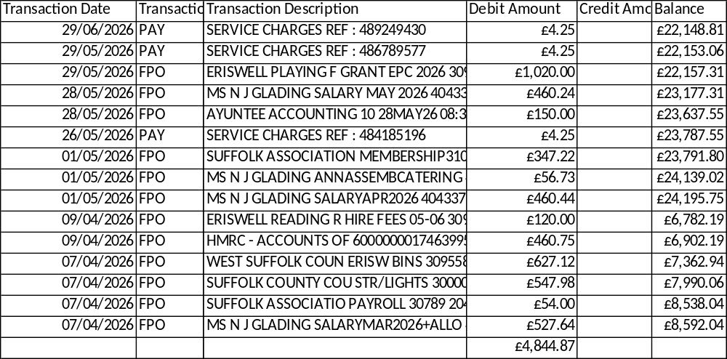

Payments In
(Precept)

Appendix D SID June Report
On 08 May 2024 at 18:00 the SID was installed on the B1112 on the pole positioned opposite the Volvo dealership, The Street, in the village of Eriswell.
The SID was positioned to monitor traffic coming from the direction Lakenheath heading South towards Eriswell Village.
Traffic speed and volumes were measured from 00:00AM 31th May 2026 up until 23:59PM on 30th June 2026.
There was between 2700 and 3200 vehicles on weekdays passing this point.
There was between 2200 and 2500 vehicles per day over the weekend heading towards the village.
The busiest times during the week was 07:30 -08:30 (Avg. 234 cars p/h) and 16:00 - 17:00 (Avg. 233 cars p/h).
The 85th Percentile Speed (most people) travel below 34.3 MPH past his point.
The 50th Percentile Speed (half the traffic) travel below 28.5 MPH past his point.
The fastest speeds recorded during this period was 70MPH (x2), 65MPH (x3) and 60MPH (x15).
The SID is positioned 670m past where the 30MPH zone starts (460m past the T-junction). The next pages show: - Speed vs vehicle counts at the point listed above. - Typical hourly volumes (weekdays) passing this point - Community Speed Watch Team Limit (35MPH) exceedances table - SID Location aerial diagram
