
ERISWELL PARISH COUNCIL
Parish clerk: Nicola Glading
Phone: 01842 337488
Email: clerk@eriswellparishcouncil.gov.uk
Website: http://eriswell.onesuffolk.net

MINUTES
Of the ERISWELL PARISH COUNCIL MEETING held on June 30th 2026 at
THE READING ROOM, ERISWELL
Present:
Cllr G Tolmie (Chairman)
Cllr J Foster (Vice Chairman)
Cllr A Bibbey
Cllr B Foster
Cllr D Horsman
Cllr A James
In attendance: Nicola Glading (parish clerk), four members of the public
Mr Andrew Moore (SCC Highways), D/Cllr G Kelly (West Suffolk Council), J Tillotson BEM (RAF)

2026/ 21 | CHAIRMANS WELCOME and RECORDING OF MEETING
2026/22 | APOLOGIES FOR ABSENCE and speaker
- Apologies for absence: C/Cllr D Waldron, Mr A Blenkiron
- The Councillors consented to accept the apologies received
 | - Short presentation on Highways works from Andrew Moore of SCC Highways (Appendix A)
2026/23 | DECLARATIONS of INTEREST
 | None
2026/24 | MINUTES OF THE MEETING HELD in MAY 2026
- The minutes of the Parish Council meetings held in May 2026 were AGREED, with an amendment to Paper C: total grant was £1020.00
The Chairman was authorised to sign the Minutes.
 | - Business remaining from the meeting not on this agenda: none
2026/25 | PUBLIC PARTICIPATION
- Members of the public may speak about specific items on this agenda or suggest future items.
- Old goal posts will be disposed of, needed to find someone with an appropriate grinder.
- Fallen branch has been reported to Elveden. Clerk to remind the estate.
2026/26 | UPDATES FROM COUNTY/DISTRICT COUNCILLORS
a. | To receive an update from the RAF representative: Engagement 6th May to enhance procurement at the UK industrial base. On 13th May, the annual ceremony for senior leadership was held. 14th May Kings Lynn service attended. 15th May: Annual football tournament. 24th May: volunteer airmen attended US Memorial Day, Lavenham airfield. 20th May: the Deputy Commander attended the Cambridgeshire Memorial service. 27th -28th May: Suffolk Show. 4th July: 48th Sqn hosting the annual Liberty Fest, open to all base personnel. 10th July: Change of Command ceremony, the chairmen of parishes have been invited.  Q: Concerns about fireworks and dry land. Long grass is like a tinderbox.  A: I will take that one up, will speak about it at scheduled internal meeting tomorrow.  Q: Concerns about a dog that constantly barks, appears distressed, in house occupied by military personnel.  A: Let the clerk have details and I will escalate; it will be dealt with
b. | Update from County Councillor Don Waldron: had given apologies
c. | To receive an update from West Suffolk D/Cllr Gerald Kelly and /or  D/Cllr Tracy Whitehead. D/Cllr T Whitehead did not attend, cllrs noted that she has attended one meeting since her election.  D/Cllr Kelly reported: several things on the go. There is an emergency full council meeting tomorrow to look at the Honington camp situation. Putting 1200 young asylum seekers that, regardless of politics or nationality, this is not best way forward. The proposal is to tell the Secretary of State that this is not the place to put these young males.  Please give some thought to the serious health implications of the current high temperatures, looking at the provision of `cool rooms` i.e. air conditioned.  Local Plan- if you go to the South of the County, they are prepared to shout – North of the A11 is a different story, need to make our issues clear.  Comment about the designated portals being clunky, not very user friendly. Increase in population in this area has been 150%, whereas in the village of Clare, population has decreased because they make their views known. Noise contours, triple SIs, buffer zone for stone curlew should have meant no development here, but people did not flag this up. Planning development is largely `bolt on` to existing areas, when perhaps the answer would be new settlements, whilst it is recognised that this would take est. 20 years, have to start somewhere.  Q: Recent request for development land? Result?  A: Don`t know as yet  Comment: Clare is not under the same pressure from landowners as we have been. Cllr Kelly replied that all landowners will look at making money.  Cllr B Foster- on approaching Clare, you won`t see the hoardings that we have to put up with. Elveden Estate unlock land round here.  D/Cllr Kelly told the meeting that Mr Shipp has put in an application to build six houses. Additionally, there was a court case about the signs on Friday, West Suffolk Council officers were in court but the case was adjourned, so the outcome is delayed.  Comment: why is he still getting away with it? Seems we have no protection whatsoever.  D/Cllr Kelly has money left in his locality budget.  Q: What has happened to the other councillor?  A: Her locality budget has been clawed back as unspent.  Cllr Tolmie: Saturday morning, there is a drop-in session at the Hub about the Local Plan. 9am to midday.
d. | To receive an update from Police Officer Scott Cameron: not present
e. | To receive an update from Mr A Blenkiron, MD Elveden Farms: not present
f. | To receive a report from Active Lakenheath Community Connectors (Appendix B) Jo Chambers told the meeting about the latest plans.
2026/27 | MATTERS RELATING TO CENTRAL PARK FUN DAY
a. | To discuss organising an LPC/ Active Lakenheath fun day  Email from Vinnie 15.06.2026 agreed use of the area.
2026/28 | MATTERS RELATING TO PLANNING
a. | Received: planning training presentation from West Suffolk Council.
2026/29 | FINANCE/ AUTHORISATION OF PAYMENTS/ DONATIONS/OTHER EXPENDITURE
a. | The expenditure for June 2026 was AGREED and the approved councillors authorised to sign off (Appendix C)
b. | Report from Internal Auditor (Appendix D) Received
c. | Report from PKF Littlejohn (AGAR 2025-2026) Received
2026/30 | SID REPORT
a. | Report from Cllr G Tolmie, manager of SID device (Appendix E) Received  Noted: Fridays and Saturdays have the most transgressors. The SID should not be turned round.  Clerk confirmed that although Mr Moore had mentioned attaching an ANPR to SID, this has been looked into previously and, in practice, the Police will not take on the data analysis.
2026/31 | CHAIRMANS and OTHER REPORTS
a. | Chairman/ Clerks report (on the night)  - Pride in Place update. (Cllr Tolmie) Kicked off the data gathering session at School Fair in new gazebo. 65 families gave feedback; PIP board members will be at every single event. Projects to be gathered by end November. Offering small community driven grants £500 to £5k. The application form is on the West Suffolk website, not currently on the LPIP site. The problem is that Lords Walk has is that there is no existing building in which a small group would have the opportunity to develop. Need to purchase some land.  - It was unanimously AGREED to renew the Asset of Community Value, tie in with the Localism Act 2011
b. | Councillors’ reports (on the night)
c. | Reports from other groups: next meeting  - Eriswell Recreation Ground Committee (Cllr Tolmie)  - Reading Room Committee (Cllr Bibbey)  - Poor’s Charity (Cllr B Foster)  - Report from Cllr G Tolmie, Eriswell Footpath Warden
2026/32 | CORRESPONDENCE/ EXCHANGE OF INFORMATION: Information may be shared (with the permission of the Chairman)  - [Scoping Consultation 2026] West Suffolk Local Plan 2045: Invitation to Join. Sent to cllrs 22/06/2026  - Approved mileage rates from tax year 2026 to 2027: Cars and vans 55ppm. Sent to cllrs 24/06/2026
Meeting closed 9pm

Appendix A
Talk on Highways works from Andrew Moore of SCC Highways
Faults (e.g. lines, signs, carriage conditions, etc.) that are reported go to the inspector, who looks to see if it meets specific criteria. If it does, an order will be placed to have it repaired, If not within the criteria, a message will be sent saying so.
TRO is a Traffic Regulation Order.
Drainage: usually go straight to the drainage people, in which case I will look at what is and what is not possible. Each gulley is on a system called caron tec, so I can find any gulley and find out when it was last done, likely to be done, issue. Timings depend on the location. There is a schedule of pumping out. People put strange things in the drainage system.
Q: Road markings- when are the markings classified as good or bad?
A: We have a Highways Maintenance Operational Plan which was put together by all the councils in Suffolk and sets the criteria on what`s done and on of what class of road. The definition of a pothole on an A road is 220ml x 200ml x 40ml deep. Response time depends on the road classification. Every road is in an inspection regime, mapped by AI.
Roads are scanned with a specialist machine. For example, a centre line has to be 80% missing. I can report back to the Asset team.
Q: speeding repeaters are damaged/ gone along Eriswell roads, ex C/Cllr Noble had agreed to replace them, but he has now gone. Non nationals tend not to be so aware of speed limits. In the past we have been fobbed off about repeaters, they go past my house at about 60mph.
Re-enforcement is needed.
A: They are in a 30 and just can`t wait. You can have signs replaced as long as you pay for it. The Reactive service manage reactive signs (entry sins, 30mph signs) The repeaters were put in about mid 90s as a plan to reduce speeds in villages, and are not often installed now. The signs are relatively cheap, c. £25, but if posts are needed and traffic management is required, it can be expensive. I can look into that for you. We cannot instal roundels where there are streetlights. I can commission a survey.
(Comment that because of the speeding, drains are also being damaged).
The SIDs can be updated to include ANPR which would need calibrating annually.
Q: Could we not get self-adhesive signs and put the posts in ourselves?
A: No.
Noted: Mr Moore commented that there is a pot of money this year in respect of traditional lines and studs. Next meeting.

Appendix B
Active Lakenheath Report
We have recently started a low impact Chair exercises group on a Friday from 2-3pm at the Bowls Club and have between 12-15 attendees. This is designed to help people with low mobility gain strength and stamina by gently building muscle so they are able to do everyday tasks easier – and it’s lots of fun too! Everyone is welcome. £3 a week and the rest of the cost is subsidised by Active Lakenheath.
Last week, Active Lakenheath took part in an end of an era event – there was a Farewell Fayre event at Lakenheath Community Primary School to mark the end of the school’s existence at the site it currently is at before the children move to its new site at the end of the village. Over 500 people attended - Active Lakenheath put on a climbing wall and Pickleball activities and Victorian games like marbles, Jacks, skipping and cup and ball games.
The Warren Walks are going well. They are held on the first Sunday of the month – in fact, it will be this coming Sunday! We meet at 9am at the picnic tables at the Warren Car Park, have a light snack and drink then walk for an hour before circling back to the car park again. Everyone welcome.
We are in the middle of planning our next Family fun day which will be held at the Pavilion in the village on Monday 10th August – there will be all sorts of lovely activities to try – all for free. It will be from 10:30-2:30pm – we are going to encourage people to bring a packed lunch and make a day of it.
In the very early stages is a possible Lord’s Walk Community Picnic on Central Park. We have been granted permission to use Central Park and hope to hold a community picnic and lots of activities there. We don’t have a date or time (apart from being over lunch - possibly Monday 24th August)
This is dependent on a lot of factors but by next month we should have it all organised so watch this space!
In the planning stages also is a Pony riding experience to be held at Apollo Stables on Saturday 12th September with crafts at the library, followed by Pony rides. Details will come out in the next few weeks.

Appendix C
Payments due | Jun-26
payee | item | amount
NG | June salary | £460.24
NG | homeworking allowance qtr 1 | £78.00
ICO | fee | £52.00
IT services | IT services | £243.50
HMRC | Tax payable qtr 1 | £600.94
A Bibbey | volunteer- plants memorial | £48.00

Appendix D
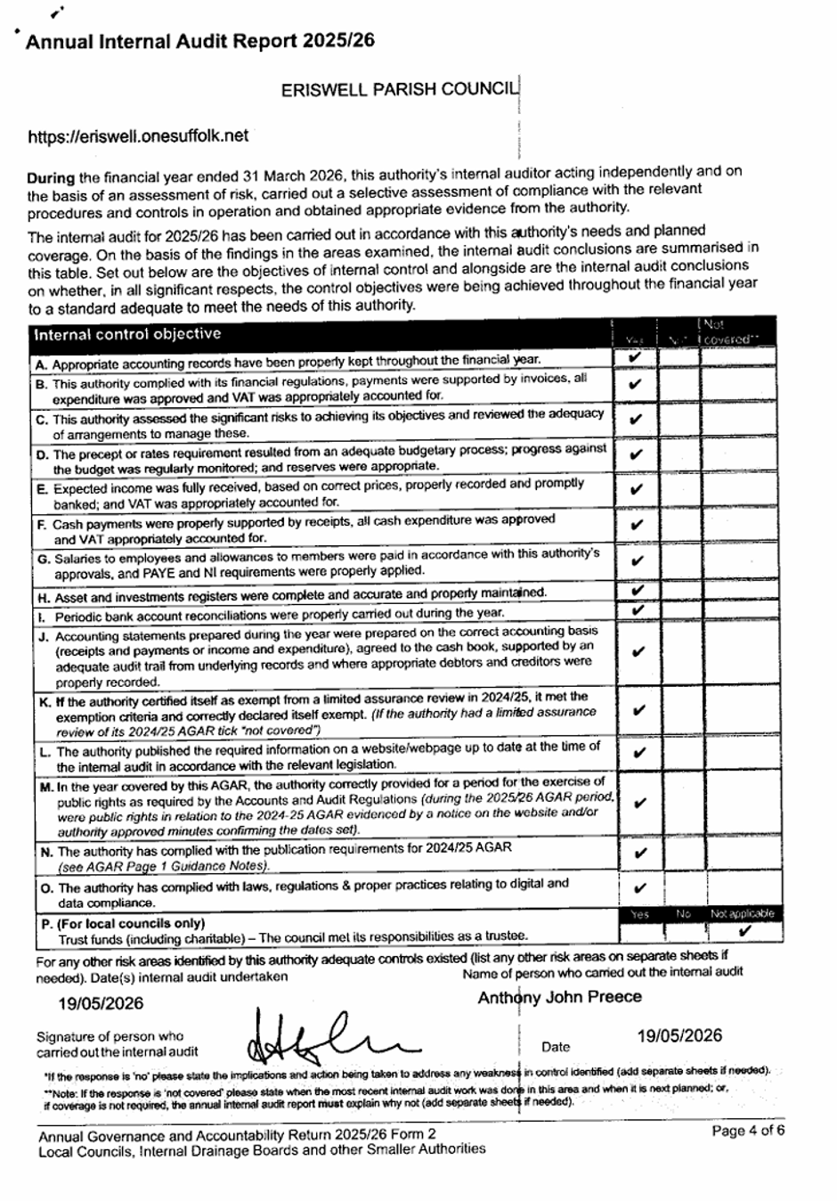

Appendix E June 2026 SID Report

On 08 May 2024 at 18:00 the SID was installed on the B1112 on the pole positioned opposite the Volvo dealership, The Street, in the village of Eriswell.
The SID was positioned to monitor traffic coming from the direction Lakenheath heading South towards Eriswell Village. Traffic speed and volumes were measured from 00:00AM 31th May 2026 up until 23:59PM on 30th June 2026.
There was between 2700 and 3200 vehicles on weekdays passing this point.
There was between 2200 and 2500 vehicles per day over the weekend heading towards the village. The busiest times during the week was 07:30 -08:30 (Avg. 234 cars p/h) and 16:00 - 17:00 (Avg. 233 cars p/h). The 85th Percentile Speed (most people) travel below 34.3 MPH past his point.
The 50th Percentile Speed (half the traffic) travel below 28.5 MPH past his point. The fastest speeds recorded during this period was 70MPH (x2), 65MPH (x3) and 60MPH (x15).
The SID is positioned 670m past where the 30MPH zone starts (460m past the T-junction).
The next pages show: - Speed vs vehicle counts at the point listed above. - Typical hourly volumes (weekdays) passing this point - Community Speed Watch Team Limit (35MPH) exceedances table - SID Location aerial diagram

