
ERISWELL PARISH COUNCIL
Parish clerk: Nicola Glading
Phone: 01842 337488
Email: clerk@eriswellparishcouncil.gov.uk
Website: http://eriswell.onesuffolk.net

MINUTES
of the ERISWELL PARISH COUNCIL MEETING held on May 26th 2026 at
THE READING ROOM ERISWELL
Present:
Cllr G Tolmie (Chairman)
Cllr J Foster (Vice Chairman)
Cllr A Bibbey
Cllr B Foster
Cllr A James
In attendance: N Glading (parish clerk, two members of the public and J Chambers, Community Connector.

2026/ 09 | CHAIRMANS WELCOME and RECORDING OF MEETING  The Chairman welcomed all to the meeting.  Clerk to record for minutes only
2026/10 | APOLOGIES FOR ABSENCE
- Councillors received apologies for absence from Vikki Quamina, John Tillotson (RAF/MOD), Mr A Blenkiron (Elveden farms MD), D Horsman, and C/Cllr Don Waldron.
- The Councillors consented to accept the apologies received.
2026/11 | DECLARATIONS of INTEREST
To receive Members’ declarations of Disclosable Pecuniary Interests
Cllrs Bibbey and Tolmie declared an interest (item 18).
2026/12 | MINUTES OF THE MEETING HELD in April 2026
 | - The minutes of the Parish Council meetings held in April 2026 were unanimously AGREED and the Chairman authorised to sign the same.
 | - Business remaining from the meeting not on this agenda: none
2026/13 | PUBLIC PARTICIPATION
- Members of the public may speak about specific items on this agenda or suggest future items. Please note: an individual’s time is limited to 3 minutes (Standing Order 1.8.5) No discussion shall take place on any question put or comment made.
- Email dated 21.05.2026 I would like the possibility of purchasing a defibrillator for the village to be discussed. Ideally perhaps this could be funded by the parish council but if not perhaps we could curate a fundraising event for it. Ideally there may need to be two, one in Eriswell and one in little Eriswell to improve the likelihood of people being able to access them promptly.
ask for more information
2026/14 | UPDATES FROM COUNTY/DISTRICT COUNCILLORS
a. | The update from the RAF representative was read out by Cllr Tolmie. Appendix A. Clerk to ask to see economic study that is mentioned.
b. | Update from County Councillor
c. | To receive an update from West Suffolk D/Cllr Gerald Kelly and /or  D/Cllr Tracy Whitehead: not present
d. | To receive an update from Police Officer Scott Cameron: not present
e. | The update from Mr A Blenkiron, MD Elveden Farms, was read out:  “Good progress is being made in the property refurbishment and we should have two houses on the rental market within the next two weeks”
f. | The report from the Active Lakenheath Community Connectors, Jo Chambers was read out. Appendix B. Clerk write to landowner about a potential one day event on the open space known locally as Central Park.
2026/15 | MATTERS RELATING TO PLANNING / consultations
a. | New Street Trading application for Amore Pizzetta trading at Shopping Centre, Earls Field, RAF Lakenheath, Brandon IP27 9RX sent to all cllrs 19.05.2026  It is believed that the trailer has now been moved.  NO COMMENT
2026/16 | FINANCE/ AUTHORISATION OF PAYMENTS/ DONATIONS/OTHER EXPENDITURE
a. | The expenditure for May 2026 was AGREED and sign off authorised.
  Payee | Item | Amount
  Staff costs | Salary May 2026 | £460.24
  Ayuntee Accountancy | Internal audit yr end March 2026 | £150.00
b. | The councillors AGREED and authorised sign off of the Annual Governance Statement Appendix C  - Section One: Annual Governance: AGREED  - Section Two: Accounting Statements: AGREED
c. | Delegation of authority to the clerk as RFO was CONFIRMED
2026/17 | SID REPORT
a. | Report from Cllr G Tolmie, manager of SID device Appendix D.  A resident has offered to be part of a Speedwatch group should one be formed. Clerk to write and thank the resident, although at present there are no plans for a Speedwatch group. The Lakenheath Speedwatch group has ceased to operate.
2026/18 | CHAIRMANS and OTHER REPORTS
a. | Chairman/ Clerks report (on the night)  - Pride in Place update since last meeting, 13 Board members have been selected, including Cllr Tolmie and A.Blenkiron. The old school is closing down. The board members are gathering information, including Neighbourhood Plan and Active Lakenheath, to put into a larger plan. The Board members were issued with a map on commencement - 65% only was included, therefore the PIP Chairman changed this. It remains to be seen what benefit Lords Walk derives from the programme. To summarise, things have been kick started with a corrected map of benefit and a small grants programme. It is not clear if the parish council can apply for funds for Lords Walk, Chair will check and keep the councillors appraised of projects. Councillors congratulated Cllr Tolmie and A Blenkiron on their appointment to the PIP Board.  - Grant application from Eriswell Recreation Ground Management Committee Appendix E. Cllrs Bibbey and Tolmie withdrew (not quorate). Further meeting to include Cllr T Harrington (Thursday).  - Radcliffe Rd streetlights lights: Each of the 9 street lights on Radcliffe Road did not have the required white label identifying them as SCC assets, however, they have now all been labelled. Numbered 435 to 443. 443 being the Lords Walk end of Radcliffe Road and 435 the Chestnut Way end of Radcliffe Road. 5 of the lights were still not functional as of last night (435 - 439) As there were no defect reports outstanding, Cllr Tolmie reported them using the SCC online tool  https://adaptors.mayriseonline.co.uk:8097/getstreet?ID=025229  (d) Cllr Tolmie has asked D/Cllr Whitehand to walk in the parish with him. Noted: that D/Cllr Whitehand has only attended one meeting since her election-  Good Morning Tracy,  “I would like to invite you to a walk around on Lords Walk and Eriswell villages to bring you up to speed on what has been happening this past year.  I am available most of Monday, Tuesday, Thursday and Friday next week (18-22/05/2026).  Are you available on any of these days?  2 hours should be sufficient.”
b. | Councillors’ reports (on the night)  None
c. | Reports from other groups  - Eriswell Recreation Ground Committee (Cllr Tolmie)  - Reading Room Committee (Cllr Bibbey)  - Poor’s Charity (Cllr B Foster)  - Report from Cllr G Tolmie, Eriswell Footpath Warden
2026/19 | CORRESPONDENCE/ EXCHANGE OF INFORMATION: Information may be shared (with the permission of the Chairman)

Appendix A RAF Lakenheath report to Eriswell Parish Council May 2026.
• To commemorate the 40th anniversary of Operation El Dorado Canyon, the 48 FW unveiled an
F-15E heritage jet. The aircraft features the specific colour scheme of the aircraft that flew the
original mission, serving as a tribute to the wing's legacy of excellence.
• RAF Lakenheath hosted 18 partner nations for the User Group Working Group. The session focused on advancing F-35 standardization in critical areas such as weapons loading and logistics supply chains to improve coalition interoperability.
• The most recent Economic Impact Statement (EIS) shows that RAF Lakenheath contributes $771.1M to the local economy and supports 2,431 jobs. The Wing remains dedicated to achieving mission success through these vital local partnerships.
• The installation employs 516 Local National Direct Hires (LNDH) with an annual payroll of £10,728,299. This represents a mutually beneficial partnership between the base, the local economy, and the UK workforce.
• In conjunction with Suffolk Highways, the RAF Commander has secured new ‘no waiting’ signs that have now been placed along the fenceline adjacent to the A1065. This is to encourage the Tail Spotters to use the car park provided and not to park illegally. We would appreciate the Parish Council’s support in encouraging the local authorities to enforce these parking
restrictions.
• Maids Cross Hill in Lakenheath is a vantage point that is sometimes used by members of the public to take photographs and videos of activity on the Base. Whilst this isn’t an illegal activity per se, it does raise security concerns. Should members of the community observe such activity we would be grateful if they could report this to the Ministry of Defence Police on 01638
546278.
• Following the unplanned protest by members of the Lakenheath Alliance for Peace on 7 April, the 48 FW is working with Suffolk Police to develop more robust plans should a similar event happen in the future.
• The Wing is most grateful for the support that the wider USVF community has received from the local community during this recent period of activity and deployments.
• The Deputy Wing Commander, Col Jurewicz, attended the County Service of Celebration with the LL of Suffolk on 18 April.
• The 48th Communications Squadron Commander attended the Breckland Council Civic Reception on 18 April.
• Wing Commander Brigadier General Arthaud attended the Cambridgeshire Armed Forces Dinner on 21 April.
• Members of the 48 FW leadership and their families attended the Tower of London and the Ceremony of the Keys by kind invite of the Yeoman Warder on 24 April.
• The 48 FW Change of Command ceremony and concurrent assumption of the US Country Representative role will take place on 10 July.

Appendix B Community Connectors Report
Active Lakenheath Community Connectors Update (May/June 2026)
Thank you everyone for your ongoing support in the work of Active Lakenheath. It has been another full month of activity and connection in the community with momentum building as we hope to move from the development phase into the full award stage of the project.
Some highlights this last month has included revisiting groups or visiting some groups for the first time to learn more about what is on offer in the community for local residents to enjoy which we have then promoted online through our Facebook ‘Group of the Week’ posts. This has been a really effective way to celebrate the great work happening in the village and to promote these local opportunities to encourage residents to access more of these wonderful groups. Some of the recent groups we have been able to advertise more have included the Flower Club and the Kids Street Dance Club which one of many dance groups being offered by the ‘Locked in Dance Company’ based at Lakenheath Pavilion.
Our Wellbeing Walks on the Warren (Maids cross Hill Nature Reserve) meeting on the first Sunday of the month at 9am are going from strength to strength and drawing people of all ages for this inclusive activity encouraging movement, connection, and wellbeing. Building on the success of recent Carpet Bowls sessions, we are now running a monthly Family Carpet Bowls After-School Club on the third Tuesday of the month at 3:30pm to 5pm at Lakenheath Indoor Bowls Club. Our first group meeting on Tuesday 19th May was attended by 15 people (6 parents or carers and 9 children). It was a very positive afternoon with many families enjoying this gentle sport for the first time and keen to continue to attend this fun and inclusive activity.
We have recently started a Parent Wellbeing Drop-In at Lakenheath Primary School for parents and carers with children attending the school. The group meets on a Friday morning once a month with the next one planned for Friday 19th June from 8:45am to 10:15am. The mornings include refreshments, chat, fun activities, information on other local groups and services, and wellbeing workshops. We are hoping to build on this with organising parent and child activity sessions at the school in the future. One particular highlight this month was the Gentle Exercise and Chair Movements free taster session we provided for local residents on Friday 22nd May at 2pm. We are so pleased to say that it was a huge success with 16 people attending who all thoroughly enjoyed the session and are keen for this to become a regular group in the village. Details of this will be available soon. Our special thanks to Aimee from Tota for leading the session and Robert from Lakenheath Indoor Bowls Club for kindly hosting the group.
We are still looking at hosting a Menopause support group hosted at the Library and are working on which day and time might suit people in the community more as a Tuesday evening only had 2 people signed up. We are working on a suggestion that Saturday might be a better option.
A lovely activity is currently being planned to host a Farewell Fayre at Lakenheath Primary School before it moves on to its new building in September. The event will be held on Saturday 20th June from 12-3pm and will involves all sorts of activities – looking back at the school’s history and also looking forward to the future – lots for the whole community to enjoy. Active Lakenheath are involved in supporting this by organising Victorian Games for the playground as well as contemporary games with a climbing wall for people to enjoy.
Looking ahead we are hopeful to receive good news soon regarding confirmation of the Full Award funding and from here we will be able to develop more new activities and opportunities in the village for local people. We are particularly keen to offer regular all-age activity sessions when people can try a variety of different games, sports, and activities which could lead to new groups or people joining existing groups. We are also planning another Family Fun Day on Lakenheath Playing Fields which will be on Monday 10th August. We look forward to confirming more details soon.
Thank you again for your interest and partnership in the work of Active Lakenheath. Together we can continue to support movement, connection, and wellbeing in our local community for the good of all and the enhancement of village life

Appendix C AGAR 2025 to 2026
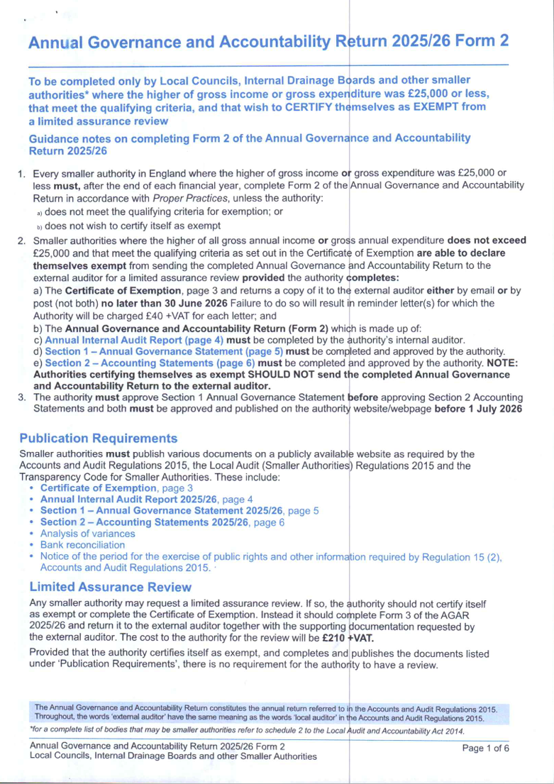
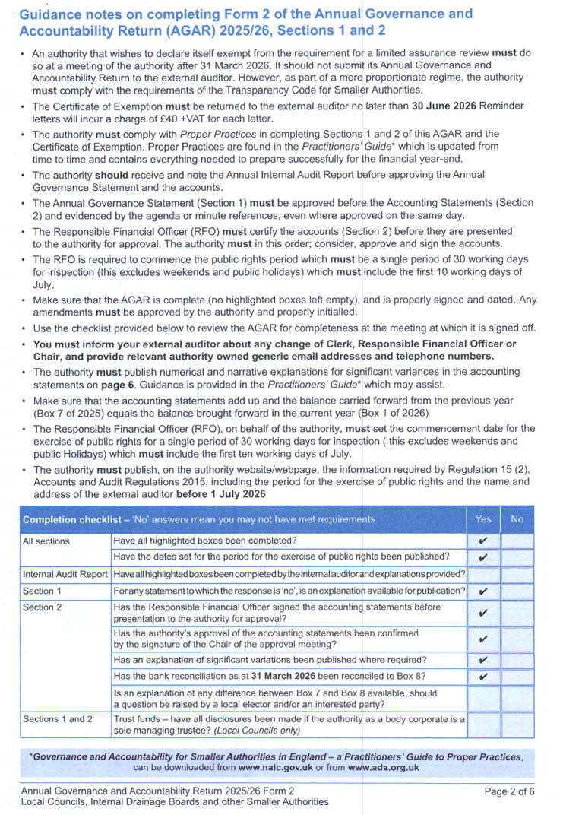

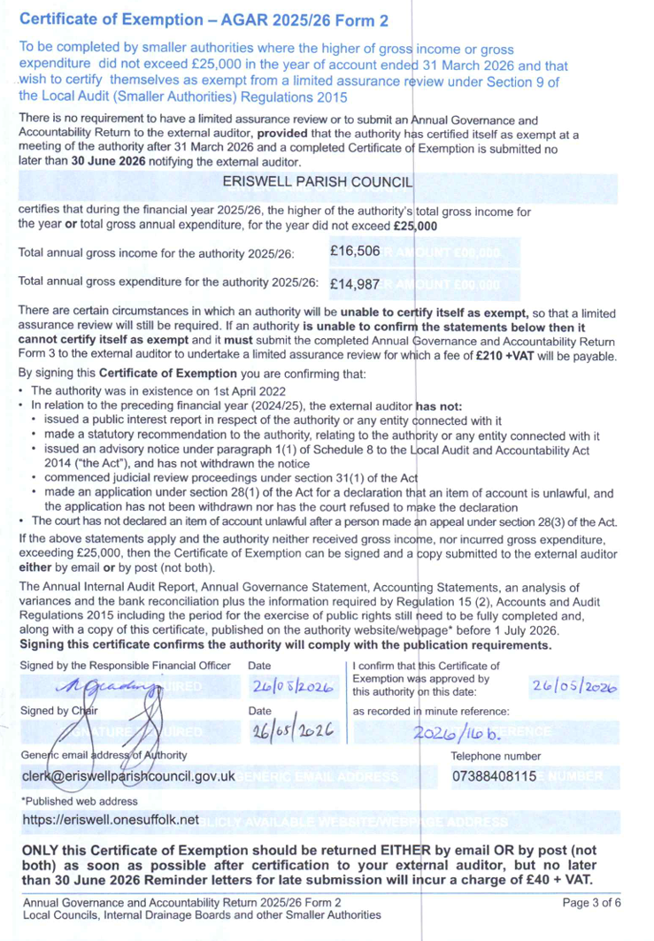
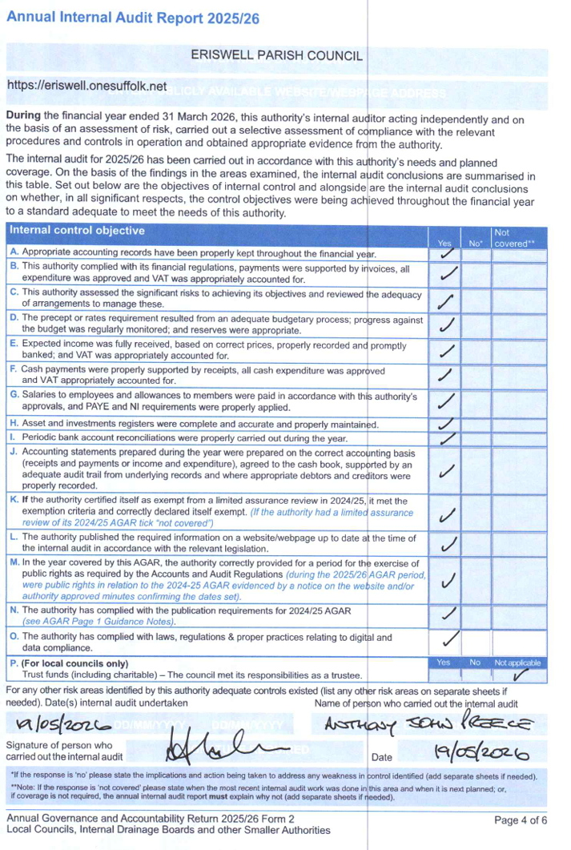
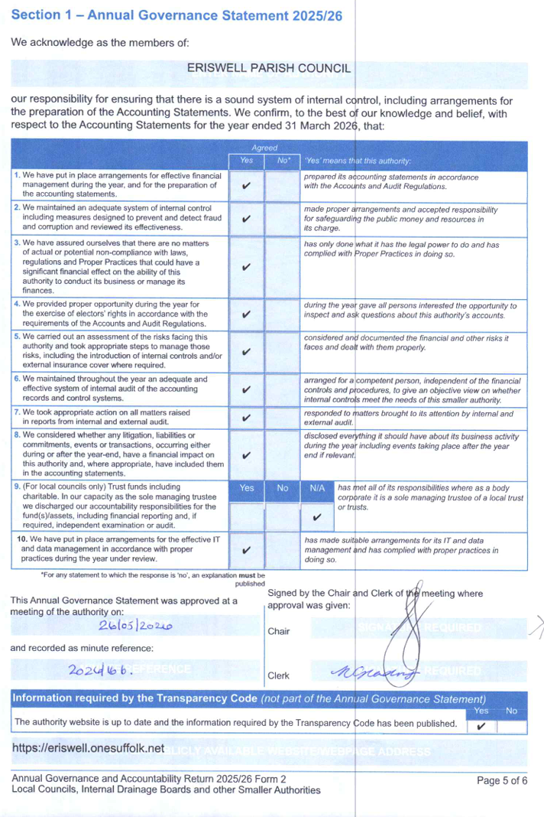
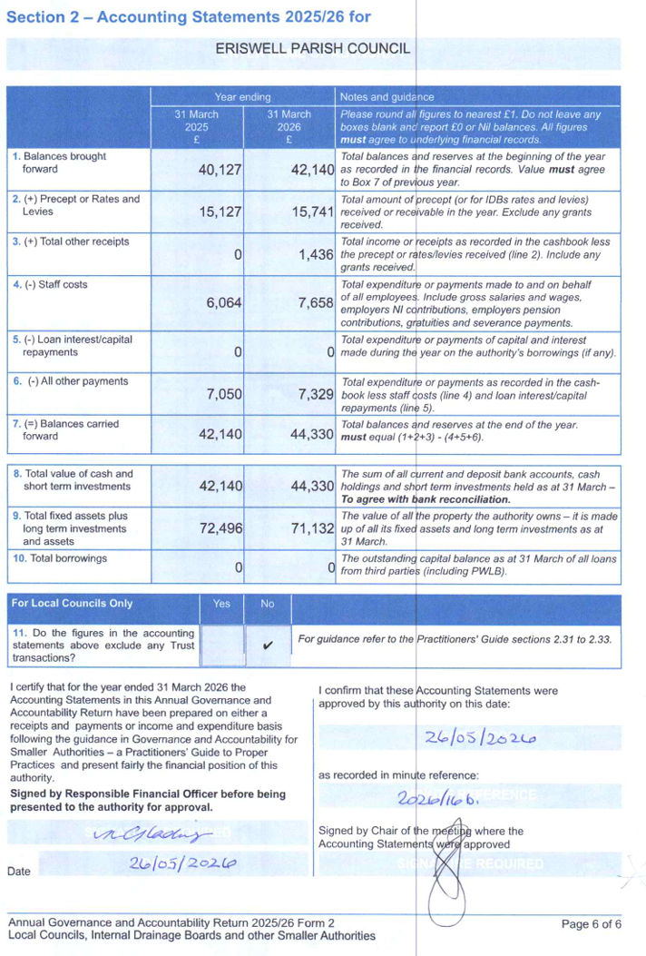

Appendix D SID Report
On 08 May 2024 at 18:00 the SID was installed on the B1112 on the pole positioned opposite the Volvo dealership, The Street, in the village of Eriswell. The SID was positioned to monitor traffic coming from the direction Lakenheath heading South towards Eriswell Village.
Traffic speed and volumes were measured from 00:00AM 31st March 2026 up until 23:59PM on 30th April 2026. There was between 2800 and 3300 vehicles on weekdays passing this point. There was between 2200 and 2900 vehicles per day over the weekend heading towards the village.
The busiest times during the week was 08:00 -09:00 (Avg. 233 cars p/h) and 16:00 - 17:00 (Avg. 252 cars p/h).
The 85th Percentile Speed (most people) travel at or below 34.1 MPH past his point.
The 50th Percentile Speed (half the traffic) travel at or below 28.4 MPH past his point.
The fastest speeds recorded during this period was 65MPH (x4) and 60MPH (x20).
The SID is positioned 670m past where the 30MPH zone starts (460m past the T-junction).
The next pages show: - Speed vs vehicle counts at the point listed above. - Typical hourly volumes (weekdays) passing this point - Community Speed Watch Team Limit (35MPH) exceedances table - SID Location aerial diagram

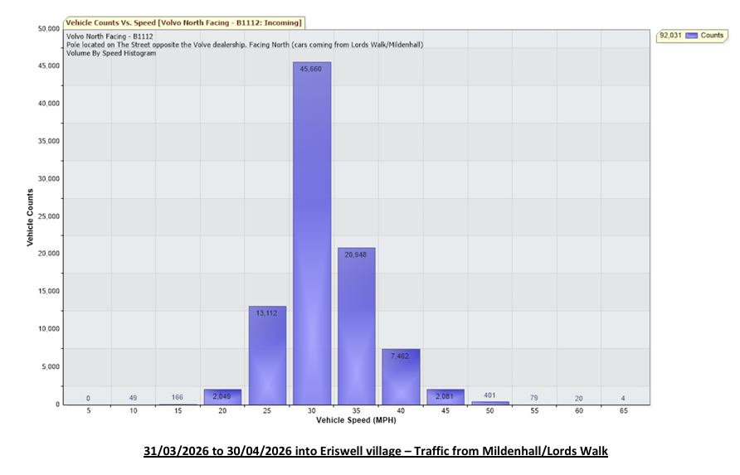
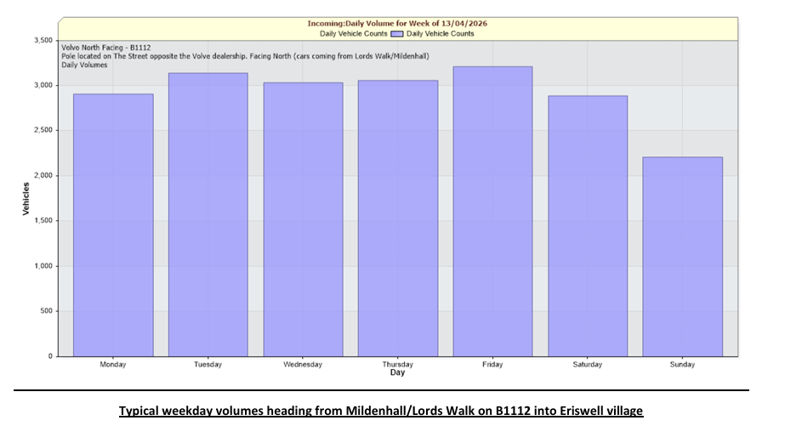
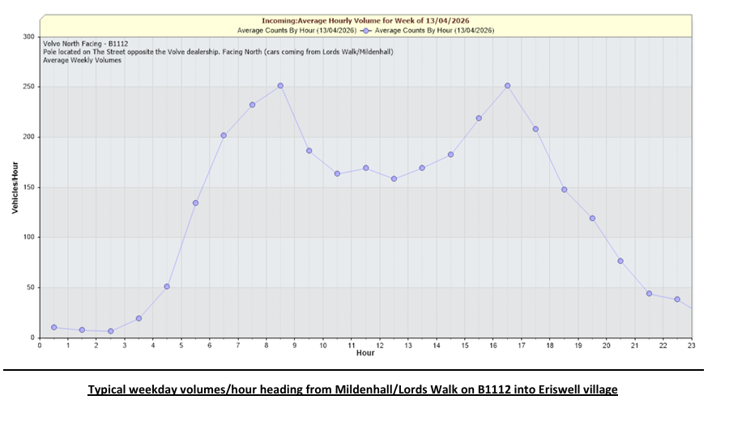

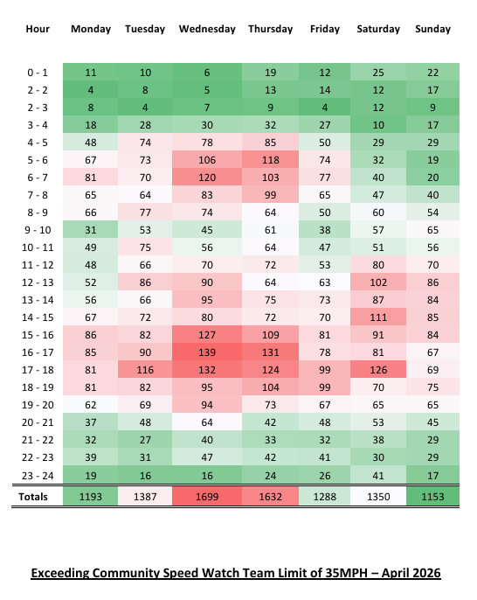

Appendix E Grant application
ERISWELL PARISH COUNCIL GRANT APPLICATION FORM
- Name of Group
- Eriswell Recreation Ground Management Committee (ERGMC)
How long has the group been operating
- Decades
Description of groups activities
- Maintenance and upkeep of recreational grounds, children’s play area, orchard, wild flower area, remembrance garden, toilet block and pavilion.
- Remove, Repair or replace worn or broken equipment.
- Raise funds for the above and any improvements.
Email Address
- Garth.Tolmie@Gmail.com
Address where you meet
- Reading Room, The Street, Eriswell, IP279BH
Telephone Number
- 07577673544
How many members/beneficiaries does the group have
- 6 members and 5000+ beneficiaries
Where do the beneficiaries live
- Eriswell Village, Lords Walk Village and Little Eriswell. Also open to USAF Liberty Village.

- Is the group run by a committee
- Yes. Garth Tolmie (chair), Nicky Glading (Secretary and Treasurer), David King, Andrew Bibbey, Pearl Brunning and Ben Samson
Is the group supported by a statutory organization
- No
Does the group have a constitution
- No
Correspondence to
- Garth.Tolmie@Gmail.com

- Finance
- Bank: Lloyds Bank Plc.
Account details
- Name: ERISWELL PLAYING FIELD COMMITTEE
- Sort Code: 30-95-58
- Account Number: 00756307
Are the accounts independently audited
- No

- Grant Application
To complete the internal renovation works of the pavillion the following are required:
- A heavy duty vinyl floor, professionally fitted.
- To purchase 2 wall panel heaters, an undercounter water heater and skirting boards. Fitment will be done by volunteers.
The above will complete the internal pavilion works and allow it to be used to generate funds.
Total Amount
£1710.60 see attached for itemized breakdown
Raised so Far
- £695.10 in cash. Volunteer hours spent on the project to date exceed 150hrs.
From where?
- Donations and savings
Requested

Signed: |  | Date:
 | Chairman

I agree to the contact details of the group being stored on the EPC database (they will not be submitted to a third party)
Signed:

