
ERISWELL PARISH COUNCIL
Parish clerk: Nicola Glading
Phone: 01842 337488
Email: clerk@eriswellparishcouncil.gov.uk
Website: http://eriswell.onesuffolk.net

MINUTES
of the ERISWELL PARISH COUNCIL MEETING held on March 31st 2026
At THE READING ROOM ERISWELL
Present:
Cllr G Tolmie (Chairman)
Cllr J Foster (Vice Chairman)
Cllr A Bibbey
Cllr B Foster
Cllr A James
In attendance: N Glading (parish clerk), J Tillotson (RAF), A Blenkiron (MD Elveden Estates) and five members of the public.

2026/ 100 | CHAIRMANS WELCOME. Clerk to record for minutes only.
2026/101 | APOLOGIES FOR ABSENCE
- Apologies for absence: PC Scott Cameron
- Councillors accepted the apologies received
2026/102 | CO-OPTION OF NEW COUNCILLOR
- Nomination and Co-option of a Parish Councillor
Nominated: Mr D Horsman
Proposed: Cllr G Tolmie
Seconded: Cllr B Foster
There were no further nominations
Doug Horsman was unanimously co-opted to the Parish Council
The Councillors Agreement was signed at the meeting by Cllr Horsman and the responsible officer.
Cllr Horsman agreed to return the completed Declaration of interest form within 30 days.
2026/103 | DECLARATIONS of INTEREST
To receive Members’ declarations of Disclosable Pecuniary Interests (as defined by the Relevant Authorities (Disclosable Pecuniary Interests) Regulations 2012)
None
2026/104 | MINUTES OF THE MEETING HELD in February 2026
 | - The minutes of the Parish Council meeting held in February 2026 were unanimously AGREED as an accurate record and the Chairman was authorised to sign the same
 | - Business remaining from the meeting not on this agenda: None
2026/105 | PUBLIC PARTICIPATION
- Members of the public may speak about specific items on this agenda or suggest future items. Please note: an individual’s time is limited to 3 minutes (Standing Order 1.8.5) No discussion shall take place on any question put or comment made.
(i) A resident asked when the bench would be installed. As a volunteer, Cllr B Foster has already put in a receiving base and he will give up more of his time to instal it, time and weather permitting.
(ii) Lords Walk front gardens: some are not well looked after, shabby, the resident told the meeting that there used to be a best kept garden competition.
(iii) Fly tipping is increasing particularly in the alleyways, it seems to coincide when three years are up and people are moving out? A friend of the resident would be happy to take to the dump; she has a large vehicle. There is a specific fly tipping report page on the West Suffolk website. If you do report, please let the clerk have the reference number.
(iv) Bins are being left out, people have to go into the road to get around them. It is not necessarily US visitors. Landlords/ Agents should be explaining expectations to tenants.
John Tillotson will speak about the issue at his information session.
Chairman and clerk will post an article on social media, asking residents
- Not to leave bins out
- To maintain gardens
- Not to fly tip unwanted articles, either take to the waste recycling area at Mildenhall or arrange for it to be collected.
It was noted that USAF personnel had been most helpful and industrious volunteers.
Chairman and clerk to write and ask for assistance from the commonly used local estate agents i.e. Balmforth, WH Brown and Chilterns.
(v) Speeding through the village: concerns about this to be looked at later in the agenda.

Duration 4.00 to 20.25

2026/106 | UPDATES FROM COUNTY/DISTRICT COUNCILLORS
a. | Update from the RAF representative: Mr J Tillotson  Mr Tilotson will send his full report to the clerk as he had not brought it with him.  There is volunteer group on Base, around seventeen people.  Airmen recently attended a care home in Feltwell, engaging with the elderly people.  Three USAF volunteers attended the Eriswell litter pick.
b. | Update from County Councillor: Awaiting election results. Currently entering purdah (from 1st April 2026)
c. | Update from West Suffolk D/Cllr Gerald Kelly and /or  D/Cllr Tracy Whitehead: not present
d. | Update from Police Officer Scott Cameron: not present
e. | Update from Mr A Blenkiron, MD Elveden Farms  Planting spring barley, parsnips, potatoes.  Rakeheath is completed.  Cost of fuel is having an impact.  Police have the ability to seize a dog if seems to be worrying stock and large fines can be imposed.  All animals on Elveden land are owned by the tenants.  Baker Nesbit is working on several Eriswell houses, so these will be on the market soon.  One bore hole is now functional.  480 ml rainfall in last year, the usual is 600 ml  Mr Blenkiron confirmed that Elveden pay for water extracted from bore holes.
f. | Active Lakenheath Community Connectors report, see (Appendix A)
2026/107 | MATTERS RELATING TO PLANNING
a. | Councillors considered DC/26/0279/FUL Planning Officer: Britta Heidecke  Proposal: Planning application - high school building including access, parking, engineering works, drainage and landscaping  Location: Land At Lords Walk Raf Lakenheath Suffolk  Applicant Defence Infrastructure Organisation  DECISION: NO COMMENT
2026/108 | FINANCE/ AUTHORISATION OF PAYMENTS/ DONATIONS/OTHER EXPENDITURE
a. | The expenditure for March 2026 was unanimously AGREED and the approved councillors authorised to sign off (Appendix B)
b. | The Quarter 4 2025-2026 Accounts were RECEIVED, (Appendix C)  - Expenditure  - Income  - Bank reconciliation  - Budget comparison
2026/109 | SID REPORT
a. | The Speed Indicator Device Report from Cllr G Tolmie, manager of SID device  was RECEIVED (Appendix D)
2026/110 | GOVERNANCE  The following policies/ procedures were reviewed:  - EPC Risk Assessment (Appendix E)  - EPC Freedom of Information Policy  - EPC Privacy Notice  - EPC Media Policy  - EPC Data Protection Procedure  - EPC Procedure for dealing with data breaches  - EPC Accessibility Statement  - EPC Code of Conduct  Information: i) Roles and Responsibilities  Unanimously APPROVED en bloc
2026/111 | CHAIRMANS and OTHER REPORTS
a. | Chairmans report:  - A successful litter picking event was held on 21st March 2026, attendees included three servicemen from USAF plus 6 volunteers, Cllr Tolmie and the clerk. Cllr Bibbey litter picked in the `old` village. 13 bags were collected.  - The Pride in Place initiative was launched at Lakenheath Annual Assembly on 27th March 2026. Lords Walk is included in the area of benefit.  - Two Earlsfield businesses have closed down, i.e. 1. Dry cleaning  2. Base Lets.
b. | Councillors’ reports:  - The tyre is still there.
c. | Reports from other groups  - Eriswell Recreation Ground Committee (Cllr Tolmie) The inspection report will now be provided every three months. Currently, all is low risk. The Pavilion near completion, we will have a celebratory event to open it.  - Reading Room Committee (Cllr Bibbey) Windows are on the way. Hopper may be cause of dampness and there are number of slates coming off the roof.  - Poor’s Charity (Cllr B Foster): fence going up. Trees need trimming: call for volunteers nearer the time  - Report from Cllr G Tolmie, Eriswell Footpath Warden: the first cut is expected at the end of April, waiting for PROW team. The Riverbank is Environmental Agency. Elveden cuts the permissive pathway.
2026/112 | CORRESPONDENCE/ EXCHANGE OF INFORMATION: Information may be shared (with the permission of the Chairman)  - Roll out of Recycling bins (West Suffolk Council)  - Town and parish council update: Call for sites (sent to cllrs 18.03.2026)  - Examples of issues the local planning authority can normally consider as a material planning consideration (sent to cllrs 18.03.2026)  - The Secretary of State has confirmed that Suffolk will have three unitary authorities.

Meeting closed 8.44pm

Appendix A
Active Lakenheath 2026 – Jo Chambers
A year ago, Rich and I had just accepted the job as Community Connector for the village and what a year it’s been. Our job role is to find out what the people of the village would like to see in Lakenheath to encourage them to be more active and hopefully, provide what residents need to make that happen. Between us, we have managed to meet and talk with nearly every official group within the village.
We have posted postcards in every house in the village, spoken with every child at the school, stood outside the Co-op, at the Pit, been to the surgery, and held drop in sessions at the library, hoping to hear from as many people as possible. We have set up a website and a Facebook page and have 132 followers already. We post posters in the Co-op, the surgery, the community notice boards around the village and at the library. We hope the word is getting around.
In terms of what activities we have managed so far, we have hosted a Family Fun day at the Pavilion last summer – we hope to do that again this summer, on a grander scale, building on what was achieved last year.
We have been to the Cubs, Scouts, Beavers and Squirrels groups in the village to run a fun and physical session with them – thanks Wendy for the opportunity, and are organising some equipment to be provided for the children there. We have run a cooking club for people on a budget, which was a team effort with Active Lakenheath and the Old Legion and Jo – with Jo being head chef and me being her sous chef! We cooked healthy meals each week and swapped recipes and ideas – it was a terrific group – and Jo organised each group member to receive a slow cooker at the end of the sessions – it was a real team effort. I’d love to repeat it. We ran a Pony riding session called Ponies, Picnic and Popcorn, providing children and adults a pony riding taster session at the stables with lunch and drinks provided. Again, a real team effort from Active Lakenheath, EPIC dad, the library and the stables, with the support from the Parish Council. It was incredibly popular and we are planning on repeating the activity later in the year for new young people and adults.
We have recently completed our first guided Warren Walk – had 26 people which was great for a first session! And it was such a lovely activity, we will be running a different walk on the Warren every month for the rest of the year. It is the first Sunday of the month – next one is May, due to Easter, and is from 9-10:30am. Meet at the Maid’s Cross car park. Snacks and drinks to start. Well behaved dogs welcome. You’d all be very welcome too!
We have run a number of sessions at the Bowls Club, making use of some new bowl equipment purchased there by Active Lakenheath twinned with a mini golf set from EPIC dad, which I believe has also been used at the school, the cooking group and during a Men’s breakfast!
We are currently working on: starting a Menopause support group, hosted at the library, more Warren Walks, Pony ride activities, hopefully another cooking group, some tuition on how to use the outdoor gym at the Pavilion – watch this space.
We also want to support and encourage new businesses in the village – there is a dance company called ‘Locked In’ , run by Locke, who is running various dance style sessions at the Pavilion for adults, new mums and babies and adults (there is a taster session this Sunday from 3:30-6:30pm) and ‘TOTA’, run by Aimee, which is low impact exercises, like chair exercises and balloon hockey for people who are possibly limited in their mobility but still want to be active. We are hoping to support Aimee to run groups at care facilities and in group settings and possibly personal sessions.
I am currently assessing walking paths in the village with a view to getting them tidied up and cleared for the village to use. Our aim is to do guided walks in the future and get some signage to help people access them for years to come. Watch this space.
We have an exciting activity coming up in a few weeks, linked with the RSPB at Lakenheath Fen. Active Lakenheath is part funding a talk and a guided walk, run by RSPB experts at the Fen on Wednesday 15th April from 9:30-11:30.

Thank you for all your support during this last year. Rich and I are incredibly grateful for all your feedback – which we hope will be used in the months and years ahead to support and encourage physical activity within the village

Appendix B Payments

Payee | Item | Amount
Suffolk County Council | Streetlights maintenance and energy | £547.98
Staff | Salary March 2026 | £501.64
Clerk | Homeworking allowance qtr 4 | £26.00
SALC | Payroll service | £53.00
HMRC | Qtr 4 P30 | £460.75
West Suffolk | Bin emptying 1/1/2026 to 31/03/2027 Three bins Lords Walk | £627.12
Reading Room Committee | Hire of Reading Room (PC meetings) 2025-6 | £120.00

Appendix C Accounts Quarter 4 2026

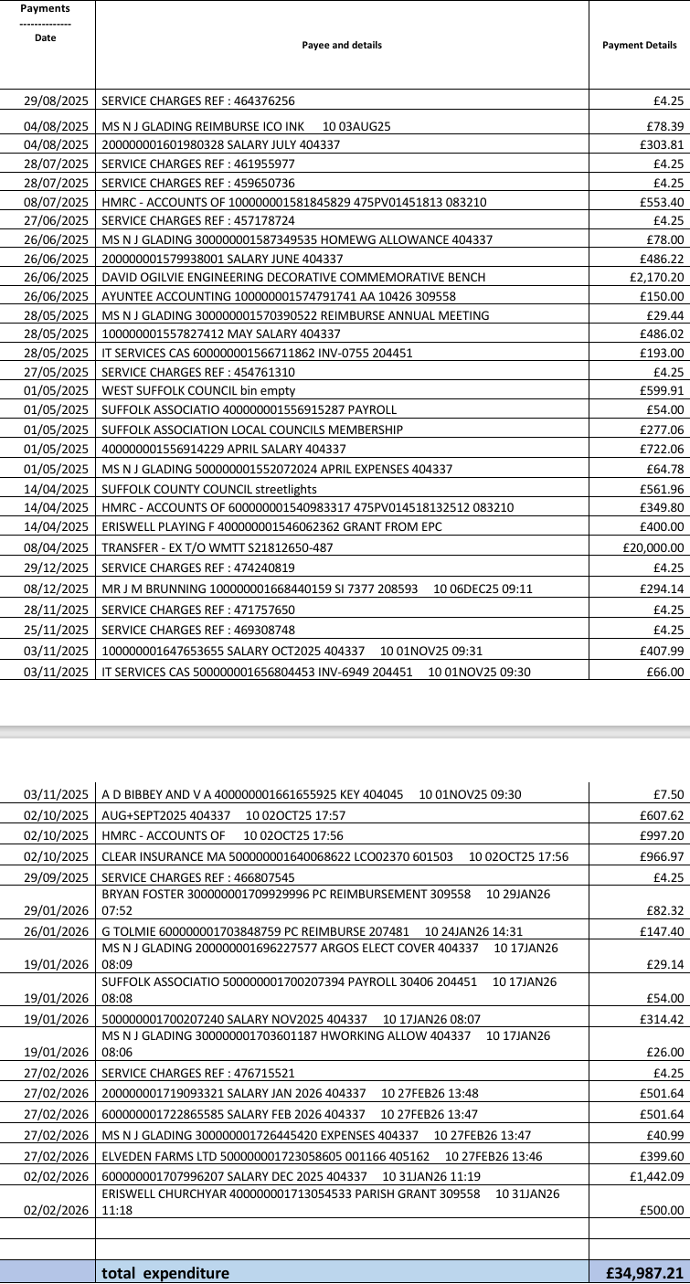
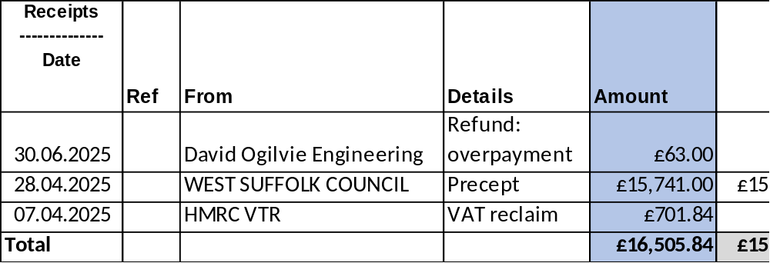

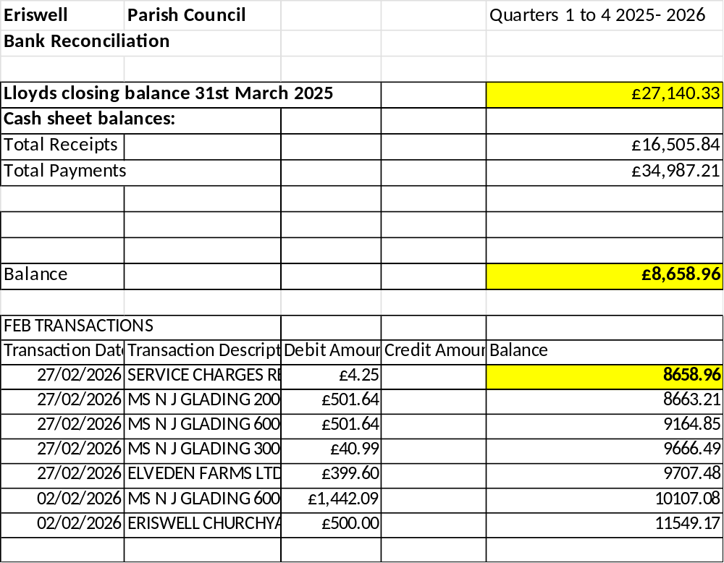

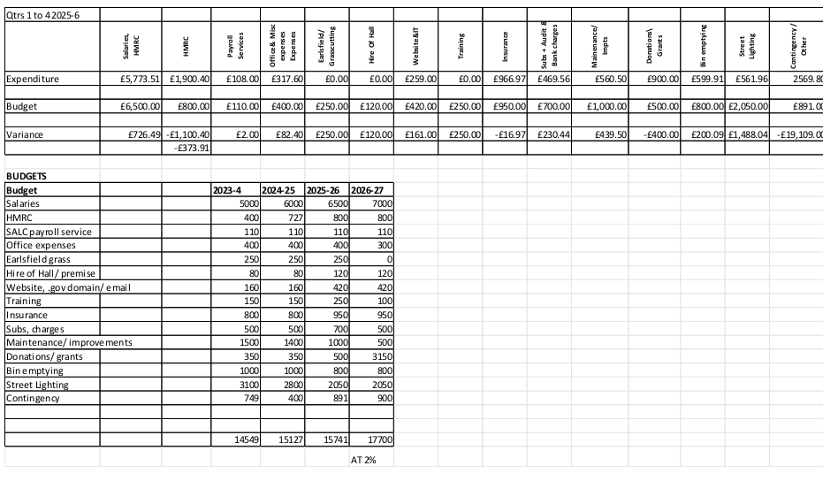

Appendix D SID Report
Paper C SID Report February 2026
The most effective places for speed monitoring are:
1. Traffic from A1065 coming into Eriswell Village. https://w3w.co/exporters.youthful.cloud https://w3w.co/daydream.hats.shout
2. Traffic through Little Eriswell going to Eriswell Village. https://w3w.co/stalemate.loses.juices
3. Traffic from Lakenheath to Lords Walk. https://w3w.co/stalemate.loses.juices
4. Traffic from Lords Walk to Lakenheath. https://w3w.co/freely.dressing.prancing
(Garth Tolmie Chaiman EPC email)
On 08 May 2024 at 18:00 the SID was installed on the B1112 on the pole positioned opposite the Volvo dealership, The Street, in the village of Eriswell.
The SID was positioned to monitor traffic coming from the direction Lakenheath heading South towards Eriswell Village. Traffic speed and volumes were measured from 00:00AM 31st January 2026 up until 23:59PM on 28th February 2026.
There was between 2700 and 2900 vehicles on weekdays passing this point.
There was between 2300 and 2700 vehicles per day over the weekend heading towards the village.
The busiest times during the week was 07:45 -08:45 (Avg. 238 cars p/h) and 16:15 - 17:15 (Avg. 256 cars p/h).
The 85th Percentile Speed (most people) travel at or below 34.0 MPH past his point.
The 50th Percentile Speed (half the traffic) travel at or below 28.3 MPH past his point.
The fastest speeds recorded during this period was 65MPH (x2) and 60MPH (x10).
The SID is positioned 670m past where the 30MPH zone starts (460m past the T-junction).
The next pages show: - Speed vs vehicle counts at the point listed above. - Typical hourly volumes (weekdays) passing this point - Community Speed Watch Team Limit (35MPH) exceedances table

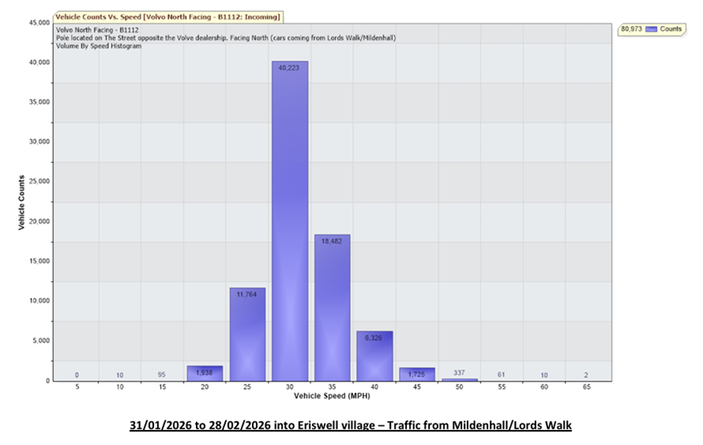
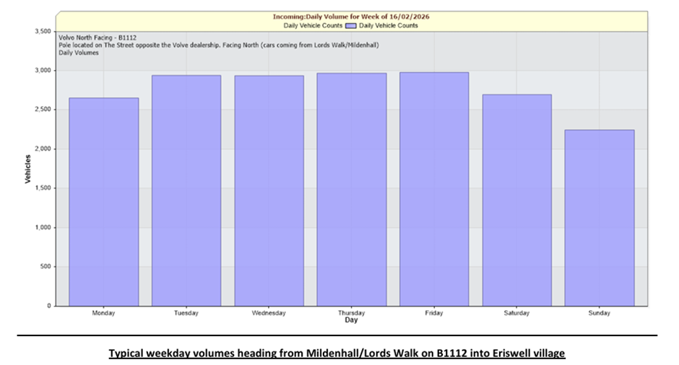
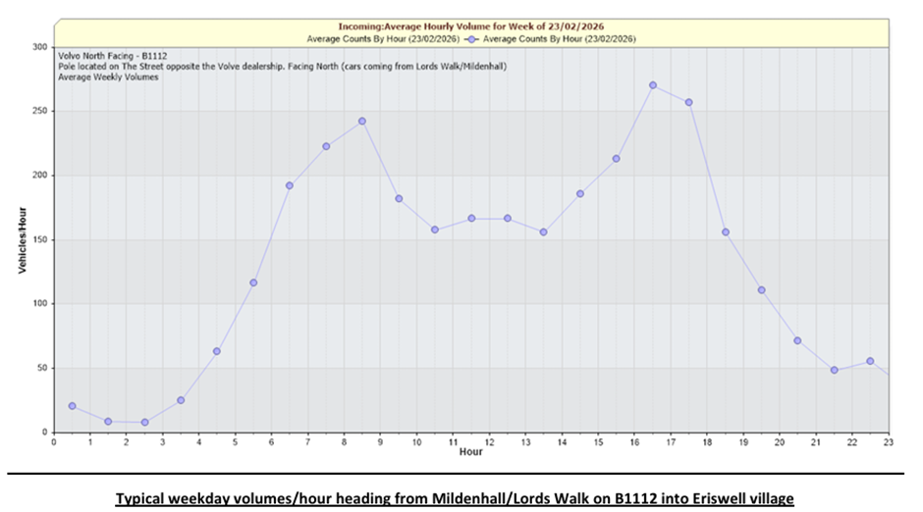
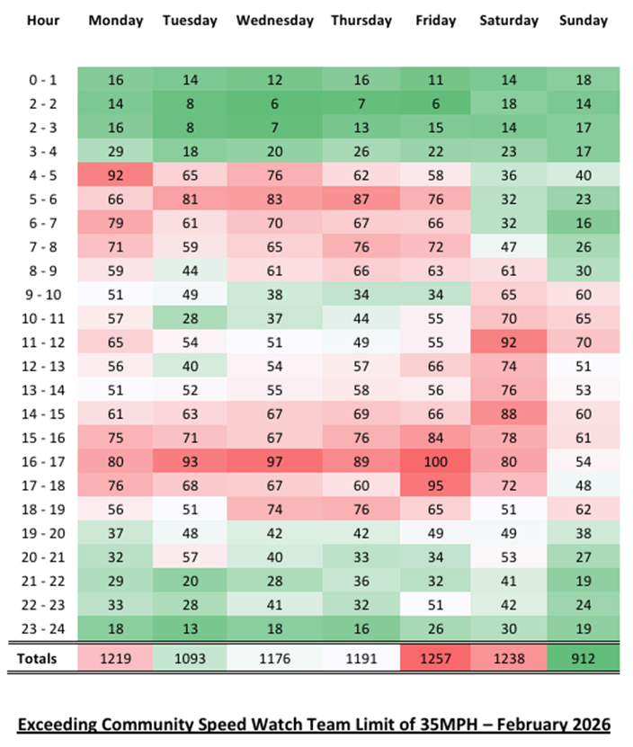

Appendix E Risk Assessment
